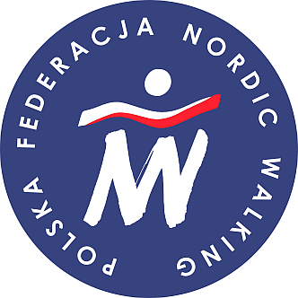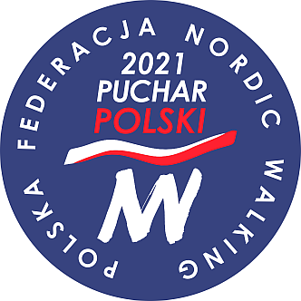

Annex No 4 to the regulation of NW Polish Cup, European Championship and Polish Championship 2021

DECLARATION OF CONSENT OF PARENTS (LEGAL GUARDIANS) TO PARTICIPATION OF THEIR CHILD/ WARD
IN NORDIC WALKING POLISH CUP, EUROPEAN CHAMPIONSHIP AND/OR POLISH CHAMPIONSHIP 2021

We, the undersigned / I, the undersigned give my consent to participation of our / my child *)

-----------------------------------------------------------------------------------------------------------------
name and surname of the child, her/his birth date

in sports competition event (competition series) ----------------------------------------------------------

-----------------------------------------------------------------------------------------------------------------

which will be held on (date/s) ……..............................………..…………………………..

……………………………………………………. in …………...…………………………..

I declare no medical contraindications regarding my child’s participation in sports competition. I give my consent to making decisions by the supervisor, organiser of the competition, related to any danger to health and life or my child.
I give my consent to collection and processing of the personal data of my child by the organisers for the purpose of organisation of Nordic Walking Polish Cup, European Championship and Polish Championship 2021, by the Polish Nordic Walking Federation and to publication of recorded images in information and materials from the referrd to competition events.

……………………………… ………………………………… …………………………
date and place signature of parent/s / guardian/s telephone number

*- if non-applicable, please, delete.

